Data Integration Background
This document provides details about data integration requirements for the CPI Card Group case study. The requirements provide details about the change data design and processing requirements.

Change Data
The job change data is an Oracle table (W_Job_Change_Data) derived from the ERP database and Customer Relationship Management system. The job change table consists of columns from the Job table in the ERP database as well as the Lead_Id from the Lead file. Table 1 provides brief comments about each column. Appendix A contains the CREATE TABLE statement.
Table 1: Columns in the W_Job_Change_Data Table
Column | Data Type | Comments
Change_Id | INTEGER | Sequence generated PK
Number_Of_Subjobs | INTEGER | Same column name in Job table
Unit_Price | DECIMAL(10,2) | Same column name in Job table
Contract_Date | CHAR(10) | yyyy-mm-yy format; Same name in Job table
Quantity_Ordered | INTEGER | Same column name in Job table
Qutotation_Quantity | INTEGER | Same column name in Job table
Sales_Agent_Id | INTEGER | Same column name in Job table
Sales_Class_Id | INTEGER | Same column name in Job table
Location_Id | INTEGER | Same column name in Job table
Customer_Id_Ordered_By | INTEGER | Cust_Key in Job table
Date_Promised | CHAR(10) | yyyy-mm-yy format; Same name in Job table
Date_Shipped_By | CHAR(10) | yyyy-mm-yy format; Date_Ship_By in Job table
Lead_Id | INTEGER | Same name in Lead file; FK to Lead_Id

The W_Error_Log table should document each change row that was not processed due to a validation error. Table 2 provides brief comments about each column. Appendix B contains the CREATE TABLE statement.
Table 2: Columns in the W_Error_Log Table
Column | Data Type | Comments
Log_Id | INTEGER | Sequence generated PK
Change_Id | INTEGER | FK to associated W_Job_Change_Data row
Job_Id | INTEGER | PK of the W_Job_F row. Used only for Lead update errors; Referential integrity not enforced
Note | VARCHAR | Brief explanation of the error.

An associated document contains CREATE TABLE statements for a test data warehouse and job change table as well as INSERT statements to populate the tables (data warehouse and job change) with a small number of rows. Note that the table and sequence names in the test tables have been changed to avoid conflicts with the production data warehouse tables. You should use the test tables initially. After you have confidence in your Pentaho transformation, you should switch to the production data warehouse tables and change data table available on the course website.

Change Data Processing

The change data processing involves insertions to the job fact table and updates to the lead fact table. In addition, error log rows should document rejected job change rows. Figure 2 shows a high-level workflow for the processing of the job change table. The assignment provides details about specific integrity checks performed by the Pentaho workflow and hints about Pentaho features to use. The workflow diagram provides an overview of the processing required.
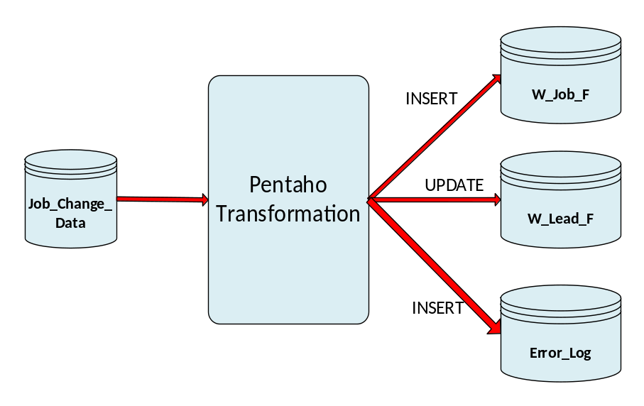
Figure 2: Workflow for Change Data Processing
The Pentaho transformation extends the transformations in module 5 of course 2. In course 2, you learned about inserting rows into a target data warehouse table after performing manipulations and error checks. This transformation updates a related table (W_Lead_F) as well inserts into an error log table to indicate processing errors.

Data Generation
Since the data warehouse design in the case study differs in some important ways from CPI Card Group’s design, using actual, de-identified data was not available. To populate the data warehouse in the case study, data generation software was developed. The data generation software contains about 3,000 lines of PL/SQL, the database programming language for Oracle. The data generation software provides flexibility for parameters including time period, dimension cardinalities, and ratios among fact tables (leads to jobs, jobs to subjobs, subjobs to shipments, and shipments to invoices), while maintaining consistency such as the job quantity to subjob quantities. The generated data are synthetic as the software uses the Oracle random number generator to create values in specified ranges. Because of careful development of the software, generated data provide a realistic experience for this course.
The data generation software also inserts rows into the job change data table. Software parameters control the cardinality as well as errors in the job change data table.
The course website contains files with INSERT statements to populate several production data warehouses and change tables. The INSERT statements were generated by the Oracle SQL Developer export tool after data warehouse tables were populated by the data generation software. Thus, you do not need to use data generation software in the capstone course.
The size of the data warehouse and change table are another extension in the case study from course 2. You should initially develop your Pentaho transformation on test data warehouse and change tables. The test tables were created manually without the data generation software. After using the test data warehouse and job change tables, you need to execute your transformation on the production data warehouse and change table generated by the data generation software.

Appendix A: CREATE TABLE Statement for the Job_Change_Data Table
-- Oracle and PostgreSQL statement for production DW
CREATE TABLE W_Job_Change_Data
( Change_Id INTEGER NOT NULL,
Number_Of_Subjobs INTEGER,
Unit_Price DECIMAL(10,2),
Quantity_Ordered INTEGER,
Quotation_Quantity INTEGER,
Contract_Date CHAR(10),
Sales_Agent_Id INTEGER,
Sales_Class_Id INTEGER,
Location_Id INTEGER,
Cust_Id_Ordered_By INTEGER,
Date_Promised CHAR(10),
Date_Ship_By CHAR(10),
Lead_Id INTEGER,
CONSTRAINT PK_JCD PRIMARY KEY (Change_Id) );

Appendix B: CREATE TABLE Statement for the Error_Log Table

-- Oracle and PostgreSQL statement for production DW
CREATE TABLE W_Error_Log
( Log_Id INTEGER NOT NULL,
Change_Id INTEGER NOT NULL,
Job_Id INTEGER,
Note VARCHAR(255) NOT NULL,
CONSTRAINT PK_Log PRIMARY KEY (Log_Id)
CONSTRAINT FK_Change_Id FOREIGN KEY(Change_Id),
REFERENCES W_Job_Change_Data );

The details are hypothetical, not directly based on the requirements faced by CPI Card Group due to difficulties to fit the actual requirements into a reasonable assignment.

